***Curriculum Vitae***

***Contact Information***

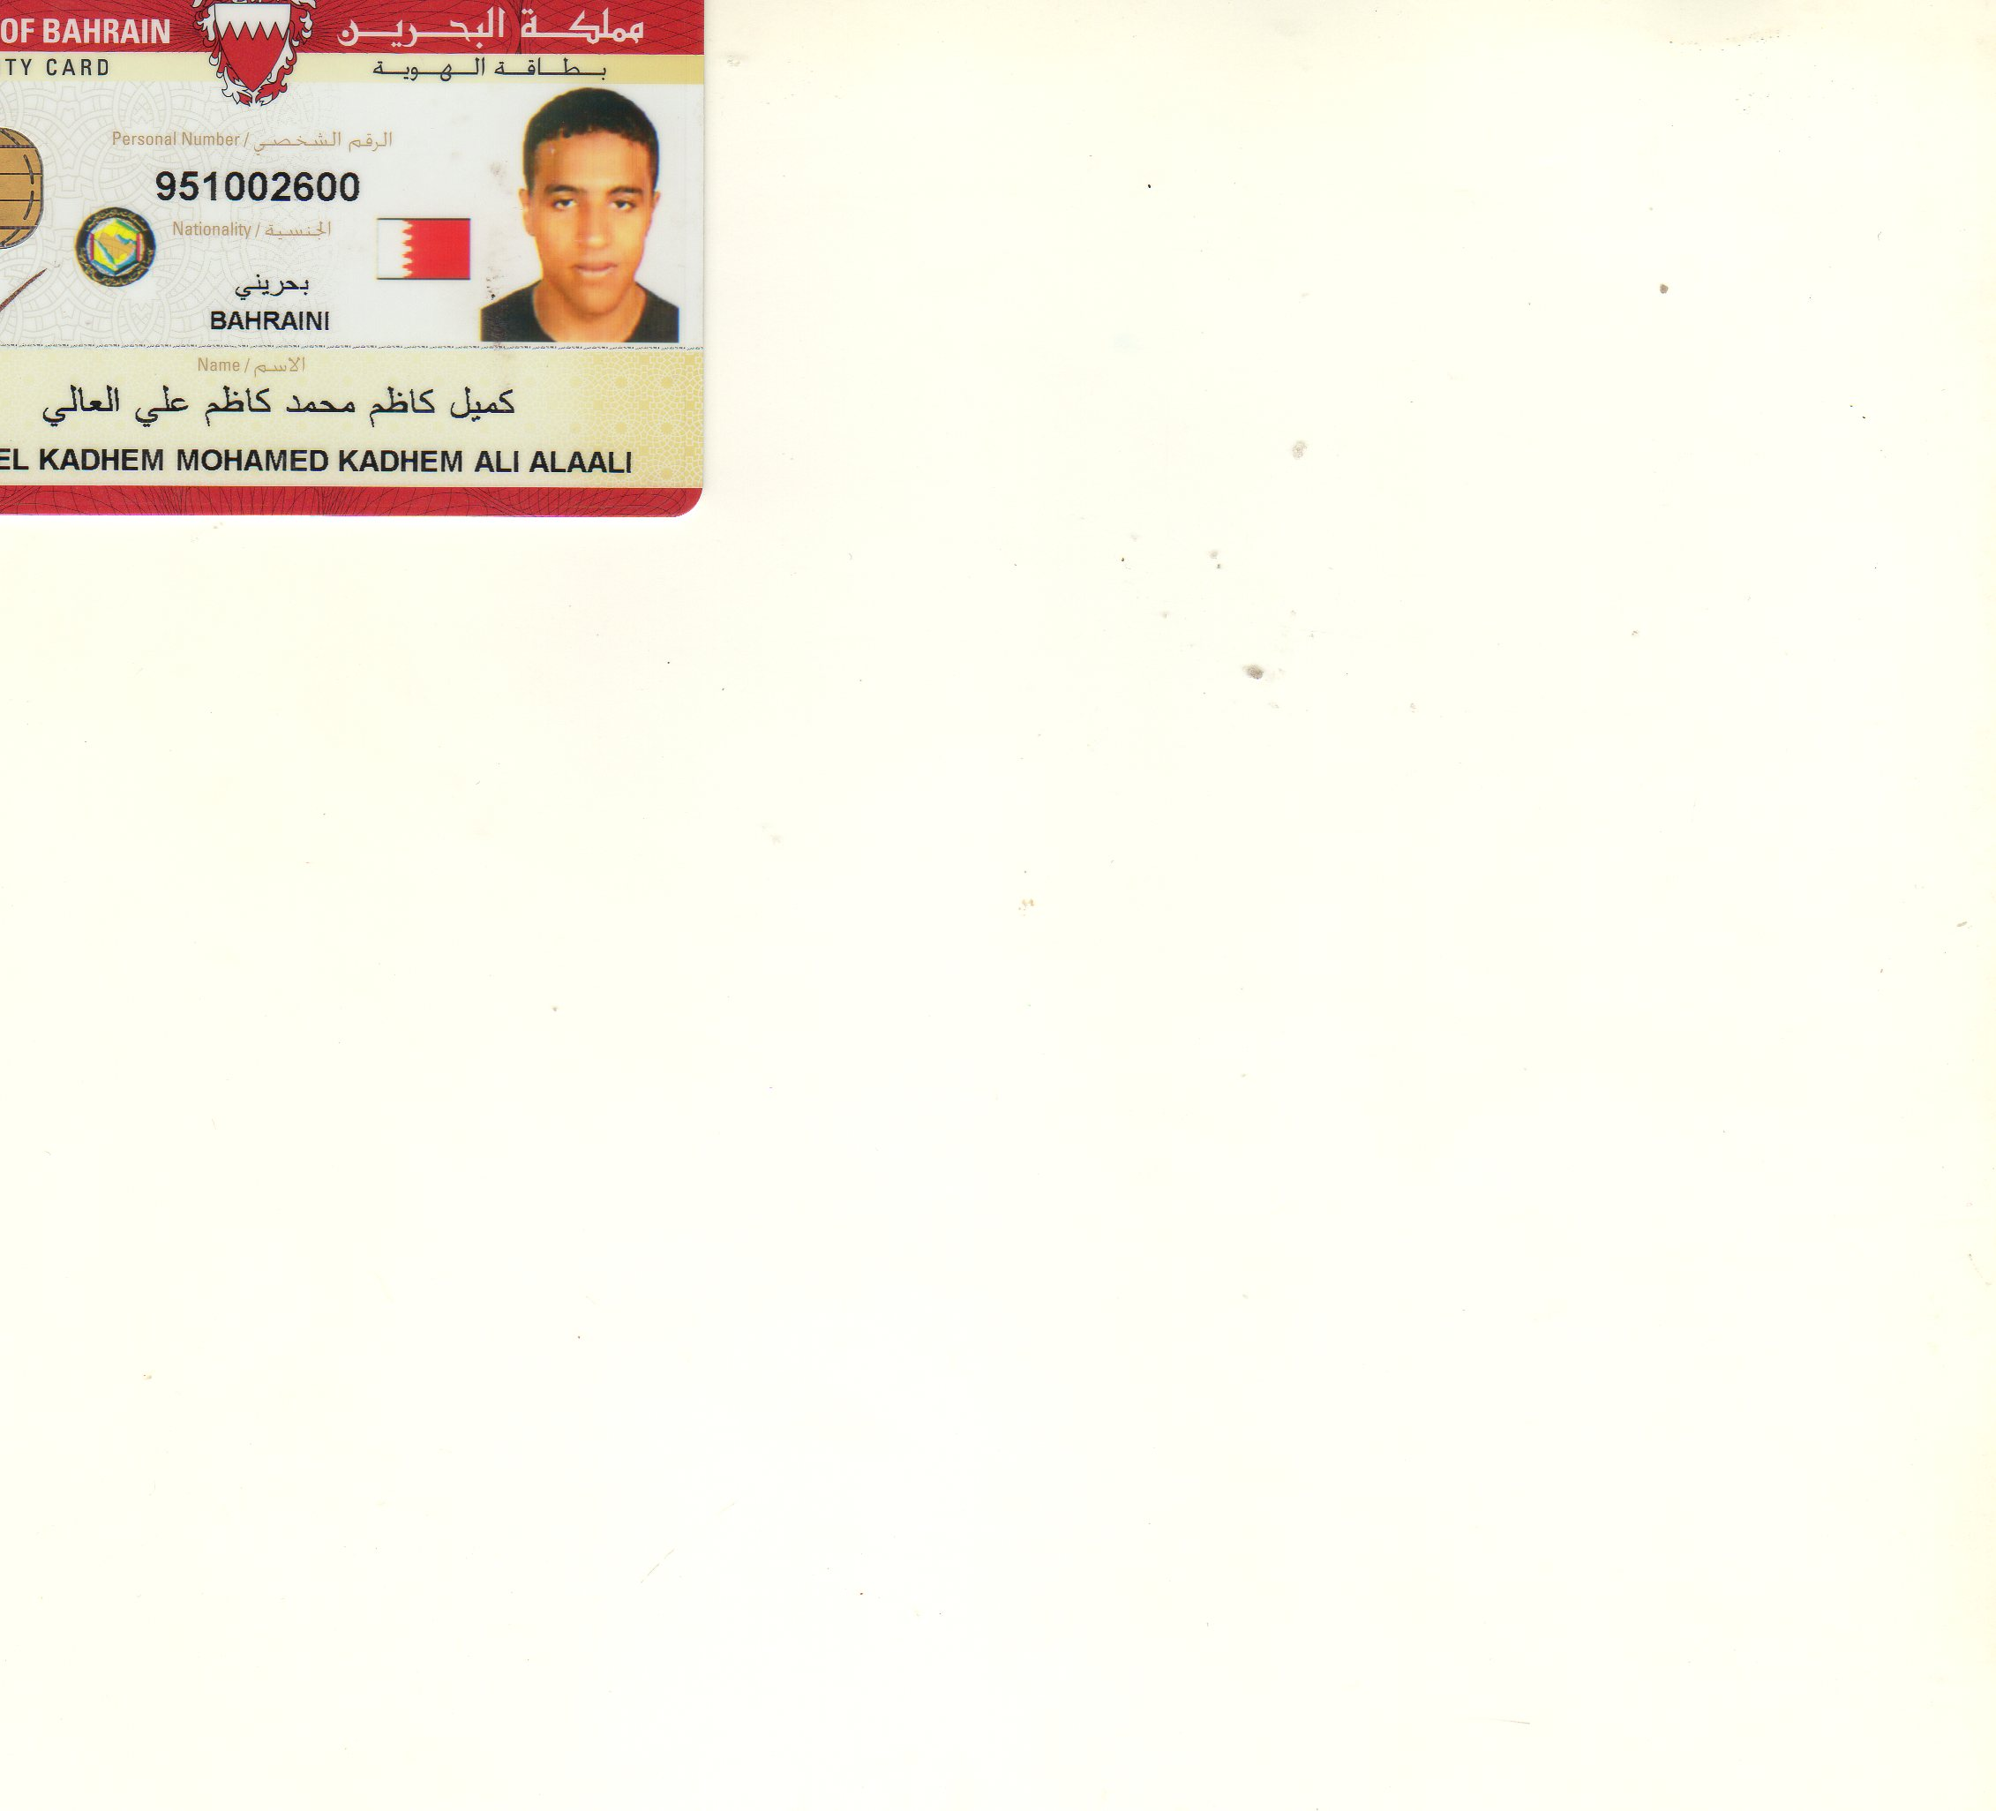***Name : Kameel Kadhem Ali Alaali***

***Address : Villa 308 , Road 1104,* *Block 1211, Hamad Town***

***Mobile : +973 66600404***

***Personal Information***

***Date of Birth : 10/10/1995***

***CPR Number : 951002600***

***Nationality : Bahrain***

***Gender : Male***

***Marital : Single***

***Objective***

***Looking forward to associate myself with an organization of quality environment where knowledge can be shared and dedicate my skills and talents for development of self and the organization served.***

***Education***

* ***High Secondary School***

***Language***

* ***Arabic Very Good Speaking and Very Good Writing***
* ***English Good Speaking and Good Writing***

***Experience***

***Cashier at Lulu Hypermarket***

***Barista at gloria jeans coffees shop***

***Professional Qualifications***

***Skills: Good people skills, driving, Tem working and Computer Microsoft Word, Good people Skills Can Working Presser***